**Our Energy Future**

|  |  |
| --- | --- |
| **Unit** | **Example** |
| Watts | Efficient lightbulb |
| Kilowatts  (102 watts) | Toaster |
| Megawatts  (106 watts) | WWII airplane |
| Gigawatts  (109 watts) | Power Plants |
| Terawatts  (1012 watts) | Global energy demand (currently 15 TW) |

**What Scales to Meet Energy Demand**

The table to the side lists different units of energy and some uses for each unit of measurement.

While the global energy demand is somewhere in the ballpark of 15 TW, this number is expected to double by 2040 as more people gain access to energy, with additional increases thereafter.

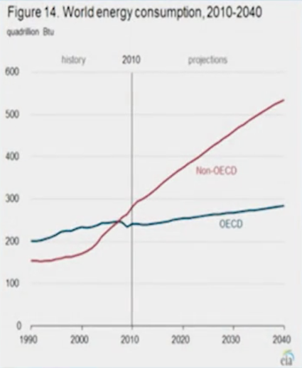To illustrate this, the graph looks at energy consumption divided by the developing world (Non-OECD, red line in graph below) and the developed world (OECD, blue line). The developing world is expected to experience a doubling of energy consumption by 2040, with a 10-20% increase in the developed world in that same timeframe.

Most of this energy currently comes from burning fossil fuels.

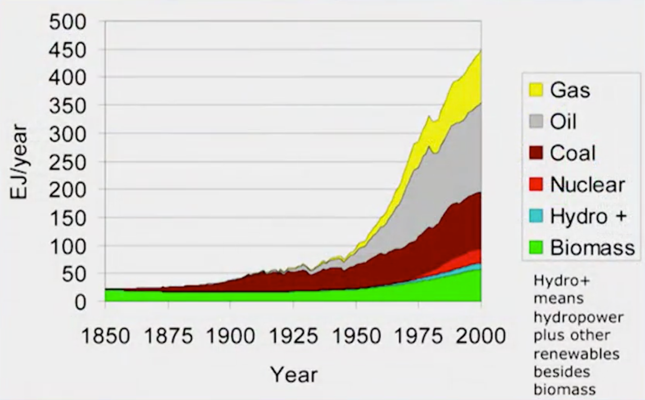

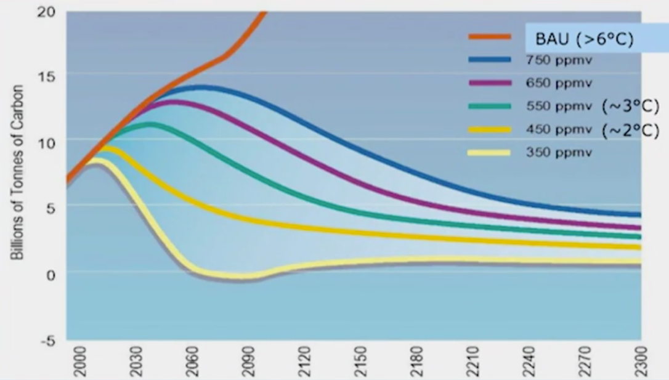The issue with this is that we emit CO2 into the atmosphere. Given the increase in expected demand with the current mix of how energy is produced today, if we were to continue on the track of how we currently produce energy (i.e., majority through burning of fossil fuels), the carbon in the atmosphere would exceed 750 ppm by mid- to late-21st century.

There is a wide array of scenarios of carbon emissions as we continue into the 21st and 22nd centuries, each of which are illustrated in the graph. To avoid the implications of high carbon in the atmosphere, we need to peak our emissions and begin to reduce them at varying rates; the different scenarios are shown in the graph.

*What will it take to meet human energy needs and avoid unacceptable global climate change?*

One metric in determining what energy sources would be useful in pursuing is to figure out which sources have the potential to meet 10% (~2000 GW) of the mid-century global demand for energy.

There are a variety of options that could be considered:

* Waves*
* Tides*
* Ocean currents*
* Ocean thermal*
* Conventional Geothermal*
* Deep geothermal*
* Food-to-ethanol*
* Unconventional fossil fuels with CCS
* “Negawatts” (increases in efficiency)
* Hydropower
* Solar PV
* Solar Thermal
* Wind
* Advanced biofuels
* Synthetic photosynthesis
* Nuclear fission
* Nuclear fusion

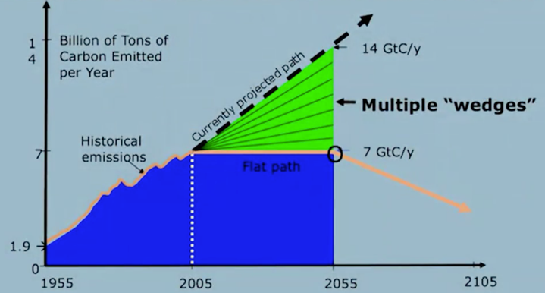*Given energy source would not be sufficient to meet 10% of global demand by mid-century. However, in some cases, in some geographies, these sources would be viable to produce considerable amount energy.

*No single source of energy or technology can be expected to meet energy demand*

It will require multiple energy sources and technologies to reach the dual goals of meeting energy demand **and** limiting carbon emissions. The chart references multiple energy “wedges” which is a strategy to reduce carbon emissions to 1.0 GtC (gigatons of carbon) per year within 50 years; any solution to the CO2 problem on a global scale should provide at least one wedge.

To underscore this point of a variety of technologies deployed to solve this problem of meeting demand and stabilizing emissions, this is one potential mix of solutions which would meet both goals:

* Record efficiency improvements (~2%/year, average of ~1% historically), totaling a reduction of 25%-50% in expected 2055 levels of electricity use in commercial/residential buildings
* 5M acres of PV (~100x today’s capacity) equivalent to 100M rooftops
* 1000s of large-scale
* 1M+ 2MW wind turbines over 2M km2
* 800 “clean coal” power plants employing carbon capture and storage (none in existence today)
* 700 new nuclear power plants (~2x current fleet) adopting next generation technologies which replace 700GW of coal power
* Replace petroleum fuels with biofuels or solar synthetic fuels
* 2-3x increase in vehicle fuel efficiency
* Nuclear fusion technology which is not in existence today

In other words, we must re-invent our entire energy economy in the next few decades if we are to make this transition, and complete fundamental research breakthroughs and innovation